 

**SMART DERM: A MACHINE LEARNING**

**APPROACH FOR SKIN DISEASE PREDICTION**

**A MINI PROJECT REPORT**

***Submitted by***

**KOMATHI R [REGISTER NO:211423104317]**

**LEAH SHARON B [REGISTER NO:211423104398]**

***in partial fulfillment for the award of the degree of***

**BACHELOR OF ENGINEERING**

**IN**

**COMPUTER SCIENCE AND ENGINEERING**

**PANIMALAR ENGINEERING COLLEGE**

**ANNA UNIVERSITY: CHENNAI 600 025**

**OCTOBER 2025**

**BONAFIDE CERTIFICATE**

Certified that this project report **“SMART DERM:A MACHINE**

**LEARNING APPROACH FOR SKIN DISEASE PREDICTION”** is the

Bonafide work of “KAVIYA R [211423104295], NANDHINI M

[211423104398]**”** who carried out the project work under my supervision.

|  |  |
| --- | --- |
| **SIGNATURE** | **SIGNATURE** |
| Dr.L.JABASHEELA,M.E.,Ph.D.,  HEAD OF THE DEPARTMENT | Dr.V.SUBEDHA,M.E.,Ph.D.,  SUPERVISOR |
| DEPARTMENT OF CSE,  PANIMALAR ENGINEERING  COLLEGE, NASARATHPETTAI,  POONAMALLEE, CHENNAI-600 123. | DEPARTMENT OF CSE,  PANIMALAR ENGINEERING  COLLEGE, NASARATHPETTAI,  POONAMALLEE, CHENNAI-600 123. |

Certified that the above candidates were examined in the Anna University Project Viva-Voce Examination held on...........................

**INTERNAL EXAMINER EXTERNAL EXAMINER**

**DECLARATION BY THE STUDENT**

We “KAVIYA R [211423104295], NANDHINI M [211423104398]” hereby declare that this project report titled “**SMART DERM:A MACHINE LEARNING APPROACH FOR SKIN DISEASE PREDICTION**”, under the guidance of Dr. K.VALARMATHI is the original work done by us and we have not plagiarized or submitted to any other degree in any university by us.

**ACKNOWLEDGEMENT**

We would like to express our deep gratitude to our respected Secretary and Correspondent **Dr.P.CHINNADURAI, M.A., Ph.D.** for his kind words and enthusiastic motivation, which inspired us a lot in completing this project.

We express our sincere thanks to our Directors **Tmt.C.VIJAYARAJESWARI**,

**Dr.C.SAKTHI KUMAR,M.E.,Ph.D** and **Dr.SARANYASREE SAKTHI**

**KUMAR B.E.,M.B.A.,Ph.D.,** for providing us with the necessary facilities to undertake this project.

We also express our gratitude to our Principal **Dr.K.MANI, M.E., Ph.D.** who facilitated us in completing the project.

We thank the Head of the CSE Department, **Dr.L.JABASHEELA , M.E.,Ph.D.,** for the support extended throughout the project.

We would like to thank our **Project Guide Dr.K.VALARMATHI** and all the faculty members of the Department of CSE for their advice and encouragement for the successful completion of the project.

**KOMATHI R**

**LEAH SHARON B**

**Abstract**

Choosing the right career path after school is one of the most significant and life-changing decisions in a student’s academic journey. Students in 10th and 12th grade often face confusion and uncertainty while deciding which stream or career to pursue. This confusion mainly arises due to a lack of proper career guidance, limited awareness of future opportunities, and insufficient understanding of their own interests, talents, and skills. As a result, many students end up making decisions based on peer pressure or societal expectations rather than their true potential and capabilities. To overcome this issue, our project introduces a Career Suggestion Website, a web-based guidance platform designed to assist school students in discovering suitable academic streams and future career paths based on their skills and preferences. The main objective of this system is to provide personalized career recommendations through a simple and interactive approach that promotes self-awareness and informed decision-making. The system begins by collecting basic information from students and categorizing them into two groups — 10th grade and 12th grade — since their requirements and decision levels differ. For 10th-grade students, the platform focuses on identifying important soft skills such as communication, creativity, critical thinking, teamwork, leadership, and problem-solving. Once the students select the skills they believe they possess, the system analyzes the data and suggests appropriate academic streams such as Biomaths, Computer Science, Commerce, or Arts. For each recommended stream, the platform further provides potential career options and a skill analysis report that highlights the student’s current strengths and the additional skills needed to excel in the chosen field. For 12th-grade students, the platform first allows them to choose their existing academic stream (for example, Biomaths, Computer Science, Commerce, or Arts) and then select both technical and non-technical skills they possess, including additional talents outside their chosen stream, such as drawing, design, or public speaking. Based on this combination of stream and skill data, the system intelligently generates personalized career recommendations that match the student’s educational background, abilities, and interests. For every suggested career, the platform provides insights into the student’s existing skills, the skills they need to develop, and the relevance of those skills to their career goal. The Career Suggestion Website aims to act as a virtual career counselor that offers guidance in an interactive, user-friendly, and personalized manner. It helps students understand their strengths, discover career opportunities they might not have been aware of, and take the right steps toward skill development. By bridging the gap between students’ current abilities and the skill requirements of various professions, the system empowers students to make well-informed academic and career decisions at an early stage. Ultimately, this project contributes to building a smarter and more self-aware generation of learners who choose their career paths with clarity and confidence rather than confusion and guesswork. The system can be further enhanced in the future with artificial intelligence and data analytics to provide even more accurate and adaptive recommendations.

**CHAPTER TITLE PAGE NO**

**NO**

**ABSTRACT** i

**LIST OF FIGURES** iv

**LIST OF TABLES** v

1.1 OVERVIEW 2

1.2 PROBLEM DEFINITION 4

2 LITERATURE REVIEW 7

3 SYSTEM ANALYSIS 3.1 EXISTING SYSTEM 13

3.2 PROPOSED SYSTEM 14

3.3 FEASIBILITY STUDY 16

4 THEORETICAL BACKGROUND

4.1 IMPLEMENTATION ENVIRONMENT 21

4.2 SYSTEM ARCHITECTURE 24

4.3 PROPOSED METHODOLOGY 27

4.3.1 DATASET DESCRIPTION 27

4.3.2 INPUT DESIGN 27

4.3.3 MODULE DESIGN 29

5 SYSTEM IMPLEMENTATION

5.1 MODULES 37

6 RESULTS & DISCUSSIONS 6.1 TESTING 43

6.2 RESULTS & DISCUSSIONS 51

7 CONCLUSION & FUTURE WORK

7.1 CONCLUSION 54

7.2 FUTURE WORK 55

A.1 SDG GOALS 57

A.2 SOURCE CODE 59

#### LIST OF ABBREVATIONS v

**1 INTRODUCTION**

**APPENDICES**

A.3 SCREENSHOTS 81

A.4 PLAGARISM REPORT 84

**REFERENCES** 85

**LIST OF FIGURES**

|  |  |  |
| --- | --- | --- |
| **FIGURE NO** | **NAME** | **PAGE NO** |
| 4.1.3 | RANDOM FOREST CLASSIFIER | 21 |
| 4.1.3 | PYTHON | 22 |
| 4.1.3 | ANACONDA | 23 |
| 4.2 | ARCHITECTURE DIAGRAM | 24 |
| 4.3.31 | USE CASE DIAGRAM | 29 |
| 4.3.3.2 | SEQUENCE DIAGRAM | 30 |
| 4.3.3.3 | ACTIVITY DIAGRAM | 31 |
| 4.3.3.4 | CLASS DIAGRAM | 32 |
| 4.3.3.5 | DFD LEVEL-0 | 33 |
| 4.3.3.5 | DEF LEVEL-1 | 34 |
| 4.3.3.5 | DFD LEVEL-2 | 37 |
| 4.3.3.6 | COLLABARATION DIAGRAM | 35 |
| 6.2 | ACCURACY SCORE | 50 |
| A.3.1 | USER INTERFACE | 70 |
| A.3.2 | SELECT SYMPTOMS | 70 |
| A.3.3 | PREDICTION RESULTS | 81 |
| A.3.4 | RESULT | 52 |
| A.4 | PLAGIARISM REPORT | 84 |

**LIST OF TABLES**

|  |  |  |
| --- | --- | --- |
| **TABLE NO** | **NAME** | **PAGE NO** |
| 6.1.1 | UNIT TESTING | 46 |
| 6.1.6 | TEST CASES | 50 |

**INTRODUCTION**

**1. Introduction**

#### 1.1 Overview:

Education is one of the most important aspects of a life and the decisions made during school years often decides the student’s entire career. After completing the 10th and 12th grade, generally students are expected to select a suitable stream or professional path. However, this is not an easy choice. Most of the students face confusion and pressure because they do not clearly understand their own strengths or the wide range of opportunities available to them. The absence of proper guidance, limited awareness of future prospects, and lack of self-assessment often lead to unsuitable or uninformed career choices.

To address this issue, our project introduces a **Career Suggestion Website** that helps students explore appropriate career options based on their class, chosen stream, and individual skills. The platform is designed to serve as a personalized guidance tool that makes career selection simpler and more meaningful.

The system first collects basic details from the student and classifies them as either 10th- or 12th-grade.

* **For 10th-grade students**, the website presents a list of important soft skills such as critical thinking, communication, creativity, and problem solving. Students can select the skills they believe they possess, and based on their choices, the platform suggests suitable academic streams like Biomaths, Computer Science, Commerce, or Arts. For each stream, potential career options are displayed along with an analysis showing the student’s current skills and the additional abilities they may need to develop.
* **For 12th-grade students**, the platform begins with their chosen stream (for example, Biomaths, Commerce, or Arts) and allows them to identify both subject-related and extra skills, such as drawing or leadership. Using this information, the system generates career suggestions that best fit their profile and highlights the skills they already have as well as those they still need to strengthen.

Overall, this project provides an **interactive, skill-based, and student-friendly guidance system**. It encourages students to understand themselves better, discover their true interests, and make informed career decisions rather than choosing paths blindly or under pressure. The website aims to bridge the gap between students’ existing skills and the competencies required for different careers, thereby helping them plan their future with greater confidence and clarity.

#### 1.2 Problem Definition:

Selecting an appropriate career path is one of the most significant and stressful decisions that students face during their school years. In particular, students in the 10th and 12th grades experience a critical stage in their educational journey, as the choices they make during this time strongly influence their future studies and professional direction. Despite the importance of these decisions, many students continue to face confusion, uncertainty, and pressure when choosing their academic stream or career path.One of the primary reasons for this confusion is the lack of proper career awareness and structured guidance at the school level. Many students do not have access to trained counselors or reliable information that can help them understand the relationship between their skills, interests, and suitable career opportunities. As a result, they often make choices based on external influences such as peer pressure, parental expectations, social reputation, or temporary trends rather than their personal strengths and interests. This leads to dissatisfaction, poor academic performance, and in some cases, the need to change fields later in life.

Another major issue is that students often have limited self-awareness regarding their own skills and potential. They may not fully recognize what they are good at or how those skills can be applied in different career paths. For example, a student who possesses creativity and good communication skills might be better suited for design or media-related careers but may remain unaware of such options. Similarly, students with analytical or problem-solving abilities may not realize their suitability for technical or scientific fields. The absence of tools or systems that help students identify their personal strengths makes it even more challenging to make confident choices.

Moreover, most schools emphasize academic results rather than skill development or career planning. Students are taught subjects but are rarely guided to connect what they learn with real-world professions. This academic pressure, combined with a lack of exposure to various career options, causes confusion and fear among students. Many of them end up choosing streams that do not align with their natural interests or abilities, leading to disengagement and frustration in the long run.

In addition, socio-economic factors and societal expectations further complicate the problem. Students from rural or less privileged backgrounds often have limited access to information about emerging career fields and end up following traditional choices such as engineering, medicine, or government jobs. This lack of exploration and awareness limits their potential to pursue careers that might better suit their talents.

Overall, the core problem lies in the **gap between students’ skills, self-awareness, and understanding of available career opportunities**. The absence of proper guidance, limited access to career information, and societal pressures create an environment where students make uninformed choices that may not reflect their true potential. This issue not only affects their academic satisfaction but also has long-term consequences on career growth, confidence, and life satisfaction.

LITERATURE

REVIEW

### 

### 2. Literature Review

1. **ISRAT YASMIN, SURIYA SULTANA, SYEDA JOBAIDA BEGUM (2023)**

Skin lesion classification plays a vital role in medical image analysis, helping to catch skin diseases like melanoma early on. While traditional deep learning models, such as Convolutional Neural Networks (CNNs), have been the go-to for a while, recent strides in Transformer-based models, particularly Vision Transformers (ViTs), are proving to be even more effective. A 2023 IEEE paper presents an innovative method that combines fuzzy logic with ViTs to boost classification accuracy. The researchers suggest breaking the dataset into three categories based on how uncertain each sample is, which allows the model to tackle each subset more efficiently and enhance its learning. This method is especially useful in medical imaging, where some lesions can look unclear or share traits with different classes. To further improve classification accuracy, the study recommends retraining classifiers mainly on samples with low fuzziness, minimizing the influence of ambiguous samples that might add noise to the training. The proposed model was evaluated using the PAD-UFES-20 dataset, a well-known benchmark in dermatological image classification. The experimental results indicate that the fuzziness-based transformer model surpasses traditional deep learning methods by effectively managing uncertainty within the dataset. Looking ahead, future research could refine this approach by testing it on more datasets and enhancing the model's ability to generalize across various skin conditions.

1. **S.ARULMURUGAN, A.M.AAMIR, K.KALANITHI** The 2024 IEEE paper titled "Skin Disease Diagnosis using Mini-batch Fuzzy C-Means Clustering and CNN" introduces an innovative approach aimed at improving the diagnosis of skin diseases. It combines Mini-batch Fuzzy CMeans (MBFCM) clustering with Convolutional Neural Networks (CNNs) to tackle the computational hurdles often faced by traditional FCM methods, while also boosting the effectiveness of CNNs in this field. MBFCM is wellregarded for its image segmentation capabilities, particularly because it can manage ambiguity effectively. However, traditional FCM can be quite demanding in terms of computation, especially when dealing with large datasets. To make things easier, the authors utilize a mini-batch strategy that lightens the computational load and speeds up convergence, making FCM more feasible for extensive medical image analysis. The MBFCM-CNN hybrid model is specifically designed to segment images of skin lesions, pinpointing areas of interest and improving the quality of the data fed into the CNN, which is responsible for extracting features and classifying them. This leads to better diagnostic accuracy. The study also highlights the potential real-world applications of this method, such as facilitating early detection and treatment planning for dermatologists, particularly in areas where specialized healthcare is hard to come by. With its reduced computational demands, this approach is well-suited for use in resource-limited environments, like mobile health platforms. In summary, the paper showcases a significant step forward in medical image analysis by merging MBFCM clustering with CNNs, effectively addressing the computational challenges of traditional FCM and enhancing the performance of CNNs in diagnosing skin diseases.
2. **S.SOFANA REKA, H.LEELA KARTHIKEYAN, A.JACK SHAKIL The**

2024 IEEE paper titled "**Exploring Quantum Machine Learning for Enhanced Skin Lesion Classification: A Comparative Study of Implementation Methods**" dives into how quantum machine learning (QML) techniques can boost the accuracy of skin lesion classification. The authors are on a mission to take traditional machine learning methods up a notch by weaving in quantum computing strategies. They utilize the HAM10000 dataset, which features 10,015 dermoscopic images sorted into seven different types of skin lesions. To make the dataset more robust and varied, they apply data augmentation techniques like geometric transformations and color space adjustments. The study investigates two main QML models: the

Quanvolutional Neural Network (QNN) and the Quantum

Support Vector Classifier (QSVC). The QNN merges quantum computing concepts with classical convolutional neural networks by adding quanvolution layers that apply quantum transformations to the input data, allowing for the extraction of intricate features. On the other hand, the QSVC model pulls features from the MobileNet pre-trained network, using quantum computing to tackle classification tasks. When comparing the performance of these QML models to several well- known classical pre-trained models, the QNN stands out, especially when it employs the RY qubit rotation alongside the Pauli-Z gate in the quanvolutional layer, achieving a classification accuracy of 82.86%. This performance surpasses all other models assessed in the study. Meanwhile, the QSVC reaches a classification accuracy of 72.5%, which is on par with the classical pre-trained modelsSkin cancer classification is a vital aspect of dermatological diagnosis, requiring advanced computational techniques to achieve high precision in distinguishing between malignant and benign lesions. Traditional deep learning models, particularly Convolutional Neural Networks (CNNs), have demonstrated significant success in medical image analysis but often struggle with capturing long-range dependencies and fine-grained spatial details. To overcome these limitations, this study introduces a hybrid deep learning approach that integrates the Swin Transformer with the Dense Group Shuffle Non-Local Attention Network (DGSNLAN) to enhance classification performance. The Swin Transformer, known for its hierarchical feature extraction and efficient self-attention mechanism, enables robust learning of global and local skin lesion features. Meanwhile, the DGSNLAN module refines feature representations by dynamically modeling spatial relationships and improving contextual awareness in medical image processing. This hybrid model leverages the strengths of both architectures, allowing for better generalization, improved accuracy, and enhanced robustness in classifying diverse skin lesions. Extensive experiments conducted on benchmark datasets demonstrate that the proposed method outperforms conventional CNN- based and standalone transformer models, achieving superior classification performance with reduced computational overhead. The study highlights the effectiveness of combining advanced deep learning architectures to create a more reliable and interpretable AI-driven diagnostic tool, ultimately contributing to early detection and improved treatment strategies for skin cancer.

1. **R.KARTHIK, R.MENAKA, SHIVANSH ATRE, JAEHYUK CHO** The

2024 IEEE paper titled "A Hybrid Deep Learning Approach for Skin Cancer

Classification Using Swin Transformer and Dense Group Shuffle Non-Local Attention Network" introduces an innovative method aimed at enhancing the accuracy of skin cancer diagnoses through cutting-edge image classification techniques. Skin cancer poses a significant global health challenge, making early and accurate detection vital for effective treatment. Traditional diagnostic methods often fall short when faced with the diverse and intricate nature of skin lesions, highlighting the need for more advanced computational strategies. In this study, the authors put forward a hybrid classification system that combines two unique neural network architectures: the Swin Transformer and the Dense Group Shuffle Non- Local Attention (DGSNLA) Network. The Swin Transformer, a type of Vision Transformer, excels at capturing hierarchical representations of images, which is particularly beneficial for medical image analysis. Meanwhile, the DGSNLA Network is a specially designed convolutional neural network that merges

DenseNet169, Group Shuffle Depth-wise (GSDW) blocks, and an Enhanced Non- Local Attention (ENLA) block. This combination effectively brings together both global and local features, resulting in a richer feature representation. To assess the performance of this hybrid model, the researchers utilized the HAM10000 dataset, a well-known collection of dermoscopic images that serves as a benchmark for skin lesion classification algorithms. The findings revealed a notable enhancement compared to traditional methods, underscoring the model's capability to accurately classify skin lesions. In summary, this study presents a groundbreaking hybrid deep learning framework that harnesses the advantages of both transformer-based and convolutional neural network architectures for skin cancer classification. By integrating the Swin Transformer with the DGSNLA Network, the approach enables robust feature extraction and representation, ultimately leading to improved diagnostic accuracy.

1. **H.M.LAYES DELOWER, TASIN MOHAMMAD, SHIFATH JAHAN**

**PRITY** The 2023 IEEE paper titled "Skin Lesion Detection and Classification Using

Machine Learning: A Comprehensive Approach for Accurate Diagnosis and Treatment" dives into how machine learning can enhance the detection and classification of skin lesions, ultimately aiming to boost diagnostic accuracy and treatment results. The study points out the increasing rates of skin cancer worldwide and stresses the urgent need for effective diagnostic tools that can help with early detection and timely intervention. The authors thoroughly analyze a range of cutting- edge machine learning algorithms, such as Decision Trees, Support Vector Machines (SVM), Random Forests, and K-Nearest Neighbours (KNN), assessing how well they perform in identifying and classifying different types of skin lesions. This research underscores the critical role of incorporating machine learning into skin lesion assessments, which could significantly propel advancements in dermatological science, leading to diagnostic systems that are not only more accurate but also faster for both dermatologists and patients. Additionally, the authors explore how machine learning models can leverage patient metadata alongside lesion images, further boosting their predictive capabilities. This comprehensive approach aligns perfectly with the growing trend towards precision medicine in dermatology. In summary, the paper highlights that integrating machine learning techniques into skin lesion detection and classification has great potential to enhance diagnostic accuracy and improve treatment outcomes.

**SYSTEM**

**ANALYSIS**

### 

### 3. System Analysis

### 3.1 Existing System:

In the current scenario, there is no proper structured or automated system to guide school students, especially those in 10th and 12th grades, in choosing the right academic stream or career path. Most students depend on traditional methods such as advice from parents, teachers, or friends, which are often based on opinions rather than a student’s personal skills and interests. This leads to confusion, poor decision-making, and dissatisfaction in their chosen fields.

Existing career counseling options are limited to manual sessions or general aptitude tests conducted in a few schools. While these provide some direction, they are not easily accessible to all students and often fail to offer personalized suggestions. Many students, particularly from rural or government schools, do not have access to professional counselors, resulting in a lack of proper career awareness.

Although a few online platforms provide career information, they mainly describe available courses and professions without analyzing a student’s individual abilities. Such systems do not match students’ skills or interests with potential career paths, leaving students to interpret large amounts of information on their own.

Furthermore, current systems do not identify the **gap between a student’s existing skills and the skills required for a specific career**. This makes it difficult for students to understand what areas they need to improve to achieve their goals.

In conclusion, the existing system for career guidance is **unorganized, generalized, and lacks personalization**. It does not provide a structured, data-based approach to connect students’ strengths and skills with suitable career paths, causing many students to make uncertain and uninformed choices.

#### 3.2 Proposed System:

#### The proposed system is a Career Suggestion Website designed specifically for school students in 10th and 12th grades to help them make informed decisions about their future academic and career paths. This platform focuses on analyzing students’ basic details, academic streams, and personal soft skills to generate personalized career recommendations.

#### In this system, students first provide their basic details such as name, class, and interest areas. Based on their input, they are categorized into two sections — 10th grade and 12th grade. Each category follows a unique process for career guidance, ensuring that students receive suggestions suitable for their current educational level.

#### For 10th-grade students, the platform presents a list of essential soft skills such as critical thinking, communication, teamwork, creativity, and problem-solving. Each skill includes a simple explanation and examples to help students identify whether they possess that skill. Based on the selected skills, the system recommends suitable academic streams such as Biomaths, Computer Science, Commerce, or Arts. Once the stream is selected, it further provides potential career options related to that stream and displays an analysis of the student’s current skill set and lacking skills required to pursue that career.

#### For 12th-grade students, the system begins by asking them to choose their existing academic stream (for example, Biomaths, Computer Science, Commerce, etc.). It then allows them to select the skills they already have, including additional talents that may not be directly related to their stream — for instance, a student in Biomaths who has artistic or design abilities. Using this combination of stream and skills, the system generates tailored career suggestions that align with the student’s abilities and interests. The system also highlights which skills the student already possesses and which skills need to be developed for each suggested career.

#### This proposed system offers an interactive, user-friendly, and personalized experience for students. Unlike the existing methods, it does not rely on generic career data or random choices but uses a skill-based approach to match students with suitable paths. By doing so, it helps students gain a better understanding of their strengths, explore diverse opportunities, and make confident career decisions that align with both their academic background and personal interests.

#### 

#### 3.3 Feasibility Study:

**3.3.1 Technical Feasibility: ---------###########**

**3.3.2 Economic Feasibility:**

The economic feasibility of the proposed Career Suggestion Website is highly favorable, as it can be developed and implemented within a reasonable budget while providing significant value to students and schools. The system can be built using open-source technologies such as HTML, CSS, JavaScript, React, Python, and MySQL, which eliminates software licensing costs and keeps development expenses low. Being web-based, the platform does not require high-end servers or specialized hardware and can run on standard computers, tablets, or even smartphones with internet access, reducing infrastructure costs. In addition, the system minimizes operational expenses compared to traditional career counseling, which often involves multiple in-person sessions, printed materials, and manual record-keeping. The platform is also scalable, allowing the addition of new streams, careers, or skills without substantial extra investment, and hosting and maintenance costs are moderate and predictable. Moreover, by providing personalized guidance, the system helps students avoid uninformed decisions that could result in additional expenses, such as changing streams or pursuing unrelated courses. Overall, the proposed system is economically feasible, requiring minimal investment while offering substantial benefits in terms of accessibility, cost savings, and career guidance.

**3.3.3 Operational Feasibility:**

The proposed Career Suggestion Website is operationally feasible because it is designed to be simple, interactive, and user-friendly, making it suitable for school students with minimal technical knowledge. The system allows students to easily input their details, select their skills, and receive personalized career suggestions without external assistance. The platform’s clear navigation, step-by-step instructions, and visual aids ensure that users can interact with it efficiently and understand the results effortlessly. Additionally, teachers and school counselors can utilize the system to support their students’ career planning, which enhances its practical utility in educational institutions. Since the system does not require continuous supervision and is accessible online from any device with internet connectivity, it can be effectively used in both individual and institutional settings. Overall, the system is operationally feasible as it meets the functional needs of students and schools while ensuring ease of use, accessibility, and efficient performance.

3.3.4 Legal and Ethical Feasibility:

The proposed Career Suggestion Website is legally and ethically feasible as it adheres to all applicable laws and regulations related to data privacy, copyright, and online usage. The system collects only basic student information, such as name, class, skills, and interests, without requesting sensitive personal data, ensuring compliance with privacy standards. Ethical considerations are carefully addressed by maintaining confidentiality of student data and preventing unauthorized access. The platform is designed to provide impartial and unbiased career guidance, avoiding favoritism or misleading suggestions. Additionally, all content, including career information, skill descriptions, and examples, is sourced from publicly available and verified educational resources to respect copyright laws and intellectual property rights. By ensuring transparency, protecting student privacy, and providing accurate guidance, the system meets both legal requirements and ethical standards, making it a trustworthy and responsible tool for educational institutions and students alike.

**3.3.5 Schedule Feasibility:**

The schedule feasibility of the proposed Career Suggestion Website ensures that the system can be developed, tested, and deployed within a reasonable and practical timeline. The project is divided into clearly defined phases, including requirement analysis, system design, database development, front-end and back-end implementation, testing, and deployment. Each phase is planned with achievable timelines, taking into account the complexity of tasks and the availability of resources. The development team can complete the core modules within the allocated schedule without compromising quality, and iterative testing during the development process ensures timely identification and resolution of errors. Additionally, the system’s modular design allows parallel development of different components, further reducing the overall project duration. Considering these factors, the proposed system is schedule feasible, making it possible to deliver a fully functional and reliable career guidance platform within the planned timeframe.

### 

### THEORETICAL BACKGROUND

**#########################**

**4. Theoretical Background**

#### 4.1 Implementation Environment:

**4.1.1 Hardware Requirements:**

* Processor: I3 and Above
* RAM: 4GB and Above

* Storage: 500GB and Above

* GPU: NVIDIA GTX1650

**4.1.2 Software Requirements:**

* **Operating System:** Windows 10 (64-bit) / Linux

* **Programming Language:** Python 3.9 or above

* **Libraries and Tools:**

1. **NumPy** – for numerical computations
2. **Pandas** – for data manipulation and analysis
3. **Scikit-learn** – for implementing Random Forest Classifier
4. **Matplotlib / Seaborn** – for data visualization
5. **Flask / Streamlit** – for web application development

• **Web Browser:** Google Chrome / Firefox (for testing the web app)

**4.1.3 Technologies Used:**

**1. Random Forest Classifier:**

Random Forest is an ensemble machine learning algorithm that builds multiple decision trees during the training process. For classification tasks, it outputs the most frequent class predicted by the individual trees, while for regression tasks, it provides the average prediction. Compared to a single decision tree, Random Forest reduces the risk of overfitting and delivers higher accuracy, especially for complex datasets, making it well- suited for symptom-based disease prediction.

In this project, the Random Forest Classifier is employed to connect the symptoms selected by users to possible skin diseases. Each decision tree in the forest evaluates the provided symptoms and predicts a likely condition. By combining the outputs of all trees, the system ensures that the final prediction is reliable, even if some individual trees make incorrect predictions. Moreover, Random Forest generates probability scores for each predicted disease, allowing the system to display the top three possible conditions along with their corresponding percentages. Its ability to handle missing values, noisy data, and high-dimensional symptom datasets makes it particularly effective for practical, real-world applications.

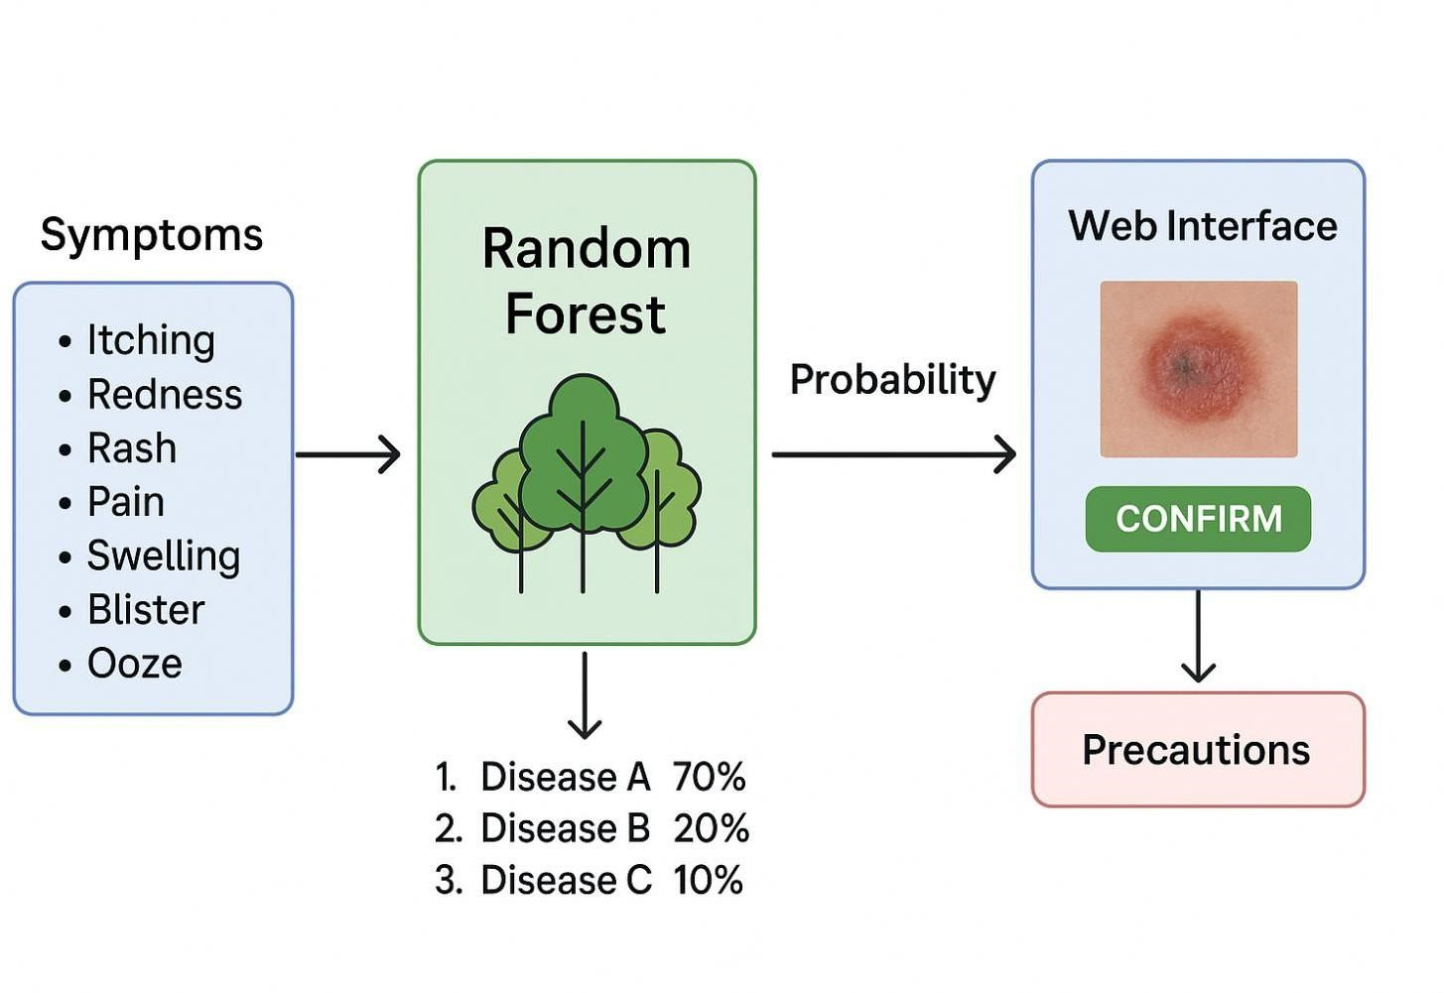

**Fig.4.1.3 Random Forest Classifier**

1. **Python:**

Python was chosen as the primary programming language for this project because of its simplicity, flexibility, and wide range of support for machine learning tasks. Libraries such as NumPy and Pandas are used to preprocess, clean, and manipulate the symptom- disease dataset efficiently. Scikit-learn provides a convenient implementation of the Random Forest Classifier, along with tools for training the model, evaluating its performance, and analyzing results.

For the web interface, Streamlit is utilized to build an interactive and easy-to-use platform. Through Streamlit, users can select symptoms, upload medical reports, view prediction results, and provide feedback with minimal development effort. Visualization libraries like Matplotlib and Seaborn are employed to display model performance, data distributions, and disease probability scores, helping in debugging and understanding the results more clearly. Python’s versatility and rich ecosystem make it an excellent choice for combining machine learning capabilities with a user-friendly web application.

1. **Anaconda:**

Anaconda is a complete development environment that makes managing packages, handling dependencies, and creating virtual environments much simpler. It comes with tools like Jupyter Notebook, which allows developers to write code step by step, test it, and visualize data and model predictions easily.

By using Anaconda, all the necessary libraries, including NumPy, Pandas, Scikit-learn, and Streamlit, can be installed seamlessly and remain fully compatible. It also supports GPU acceleration, enabling faster training of machine learning models. Additionally, Anaconda allows developers to create isolated environments for different projects, minimizing conflicts and ensuring reproducibility. Overall, Anaconda’s strong environment management makes both the development and deployment of the skin

disease prediction system efficient, reliable, and scalable.

**Fig4.1.2 Anaconda Navigator**



#### 4.2 System Architecture:

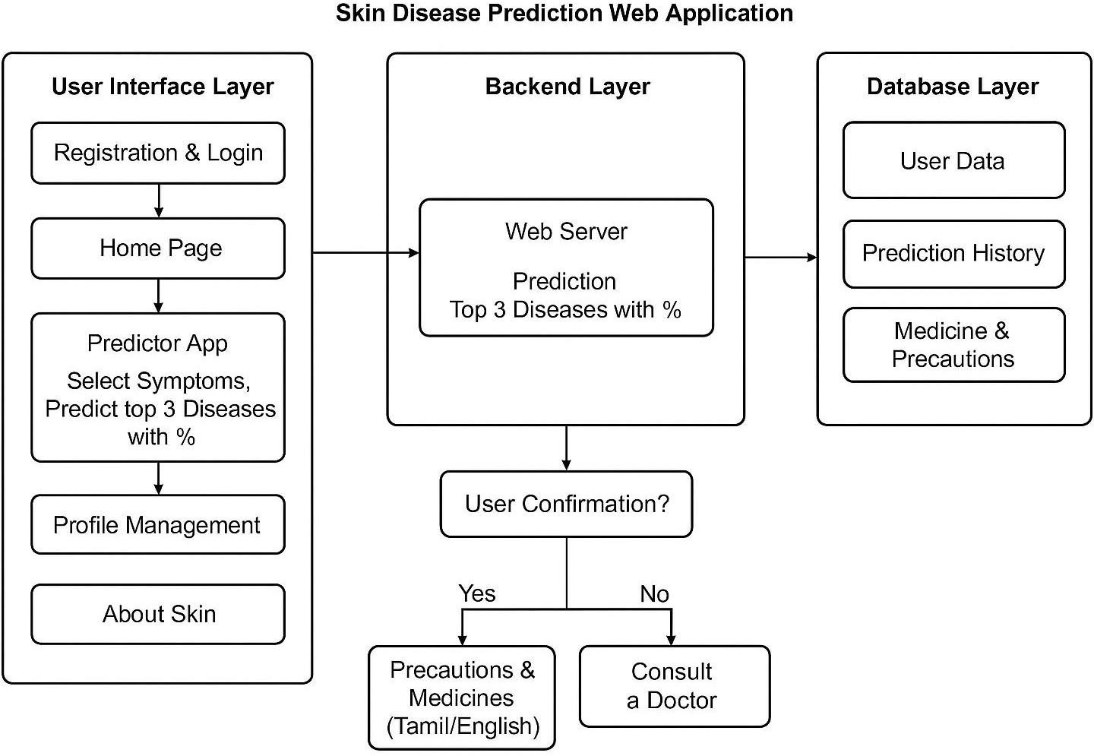

**Fig4.2 Architecture Diagram**

The Skin Disease Prediction System is designed as a comprehensive web-based application that seamlessly integrates an interactive user interface with a robust machine learning model to provide accurate, real-time, and user-friendly predictions for skin diseases. The system is aimed at both patients and healthcare professionals, offering a convenient platform to assess symptoms and receive initial diagnostic guidance while maintaining data privacy and ethical standards. Users begin by registering on the platform, creating a secure account that allows them to log in and access the system’s features. Once logged in, users can select symptoms from an extensive and well- organized list on the Predictor App page. This design ensures that even individuals with minimal technical knowledge can navigate the system effortlessly and input their health information accurately.

Once the symptoms are submitted, they are transmitted to the backend server, which communicates with a Random Forest Classifier trained on a curated dataset containing symptom-to-disease mappings. This ensemble machine learning model evaluates the input symptoms and predicts the top three most probable skin conditions. Each prediction is accompanied by a confidence percentage, indicating the model’s level of certainty, and representative images of the predicted diseases are displayed to help users visually confirm the results. By providing both numerical probabilities and visual aids, the system enhances user understanding and builds trust in the AI-assisted predictions.

A notable feature of the system is the feedback mechanism, which allows users to confirm or reject the predicted diseases. If a prediction is confirmed, the system provides users with precautionary measures and suggested medications to manage their condition effectively. If the prediction does not match the user’s observations, the system advises consulting a qualified healthcare professional, ensuring that the platform serves as a reliable support tool rather than a replacement for professional medical evaluation. This ethical approach ensures that users are aware of the AI’s limitations while benefiting from its predictive capabilities.

Beyond prediction functionality, the system includes several additional features to enhance usability and engagement. Users can update and manage their profiles, upload medical reports for reference, and access educational content about various skin diseases to better understand their conditions. The platform also offers bilingual support in Tamil and English, catering to a wider audience and improving accessibility for non-English speaking users. All user information, including prediction history and uploaded reports, is securely stored in a database, maintaining the integrity and confidentiality of sensitive health data. The backend, frontend, and machine learning modules are tightly integrated, ensuring smooth communication, fast response times, and a real-time interactive experience.

The modular design of the application allows for future enhancements, such as adding new disease categories, integrating telemedicine support, or incorporating additional AI models for image-based analysis. By combining advanced machine learning techniques with a well-structured and interactive web interface, the system bridges the gap between automated diagnostic tools and practical patient-centered healthcare solutions. Its lightweight architecture ensures that it can run efficiently on standard computing devices, making it accessible to a broad range of users without requiring specialized hardware.

In summary, the Skin Disease Prediction System provides a reliable, practical, and ethical solution for early detection of skin conditions. By integrating accurate symptom- based predictions, visual confirmation tools, user feedback mechanisms, educational content, and bilingual support, the system not only enhances patient engagement but also supports healthcare professionals in delivering timely guidance. Its scalable and modular design ensures that it can adapt to future healthcare needs, making it a valuable tool in the advancement of AI-assisted medical applications.

#### 4.3 Proposed Methodology:

##### 4.3.1 Dataset Description:

The dataset used in this project was obtained from Kaggle and provides a comprehensive collection of skin disease symptoms along with their corresponding diagnoses. Each record in the dataset contains multiple symptoms linked to a particular skin disease, allowing the model to identify meaningful patterns and make accurate predictions. Before using the data, it was carefully preprocessed to remove irrelevant, duplicate, or inconsistent entries. Only skin-related symptoms and diseases were retained to ensure that the model receives high-quality, relevant input, which is essential for improving the accuracy of the Random Forest Classifier.

To train and evaluate the model effectively, the dataset was split into training and testing sets. This allows the Random Forest Classifier to learn patterns from one portion of the data while being tested on unseen examples to measure its performance. Additionally, balancing techniques were applied to address any class imbalances, ensuring that the model does not become biased toward certain diseases. This careful preparation of the dataset helps the system provide fair and reliable predictions across all categories, making it a robust tool for symptom-based skin disease prediction.

##### 4.3.2 Input Design:

The system’s input design is carefully crafted to make user interaction as smooth and intuitive as possible. Users engage with the platform through a web- based interface built using Streamlit, which provides a simple and interactive environment for entering their symptoms. When using the system, users first select the symptoms they are experiencing from a comprehensive list of validated options.

To ensure accuracy, the system checks the input for completeness and correct formatting, helping to prevent errors before the data is processed. Once validated, the selected symptoms undergo preprocessing to prepare them for interpretation by the machine learning model. This step ensures that the data is clean, structured, and ready for reliable prediction.

After preprocessing, the input is sent to the Random Forest Classifier, which analyzes the symptoms and predicts the top three most probable skin diseases. Each prediction is accompanied by a confidence percentage, giving users a clear understanding of the likelihood of each condition.

If the input is incomplete or invalid, the system immediately provides feedback and prompts the user to correct it, ensuring that the process remains accurate and efficient. By combining careful input validation, preprocessing, and real-time feedback, the system delivers a seamless, reliable, and user-friendly experience while maintaining high prediction accuracy.

##### 4.3.3 Module Design:

**4.3.3.1 Use Case Diagram:**

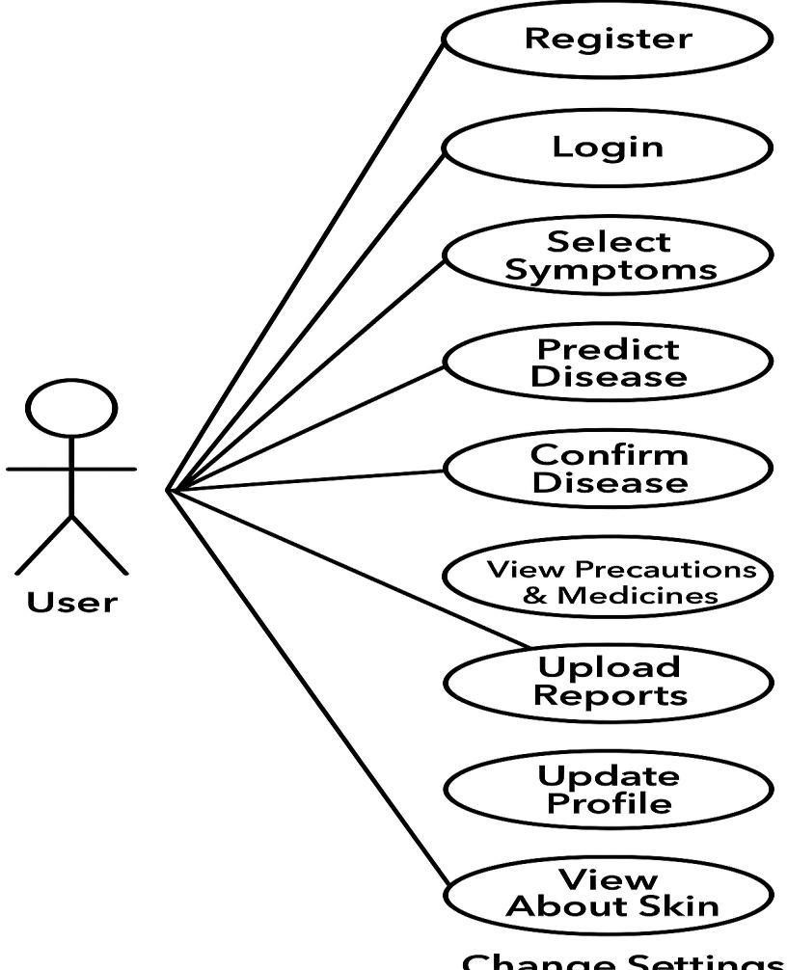

**Fig.4.3.3.1 Use Case Diagram**

**4.3.3.2 Sequence Diagram:**

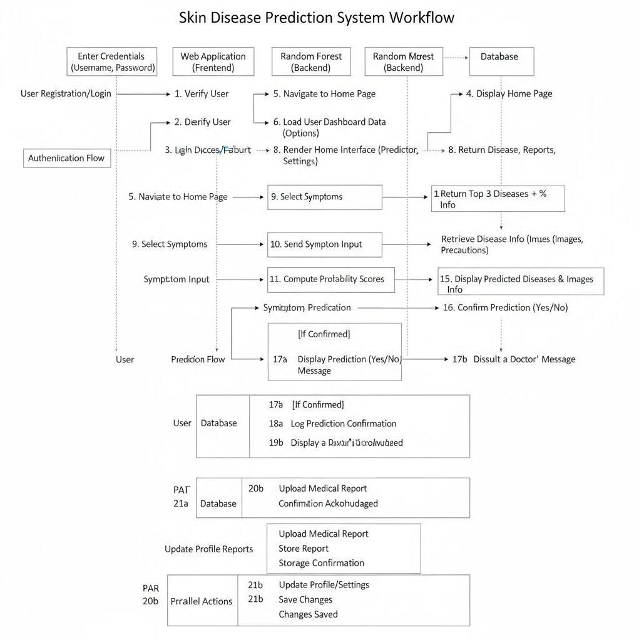

**Fig.4.3.3.2 Sequence Diagram**

**4.3.3.3 Activity Diagram:**

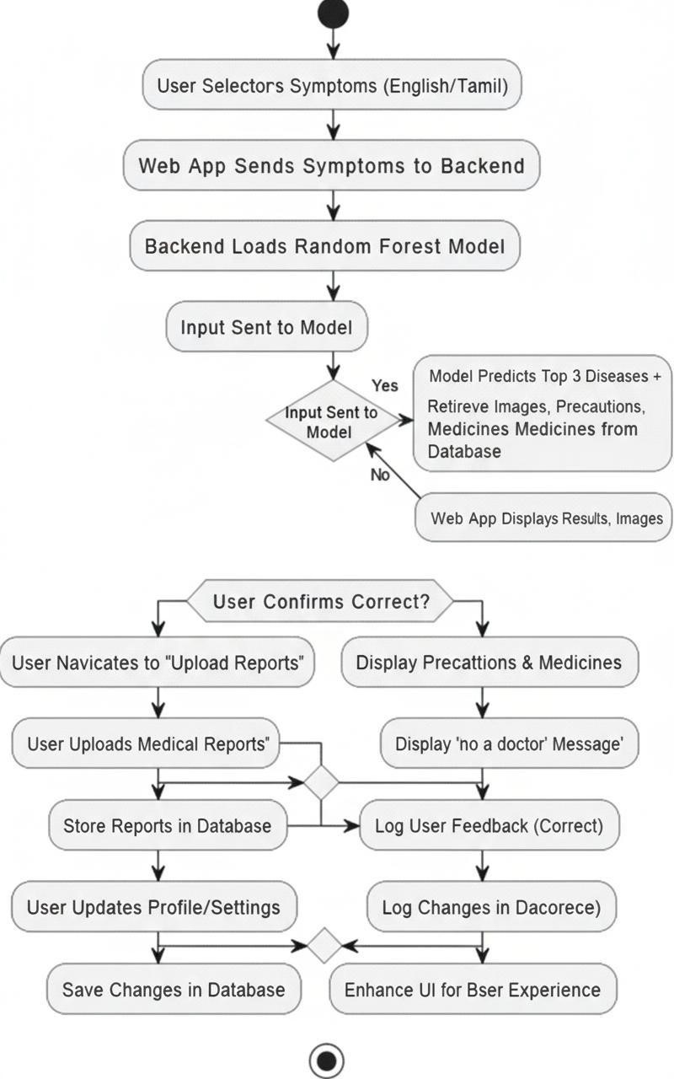

**Fig.4.3.3.3 Activity Diagram**

**4.3.3.4 Class Diagram:**

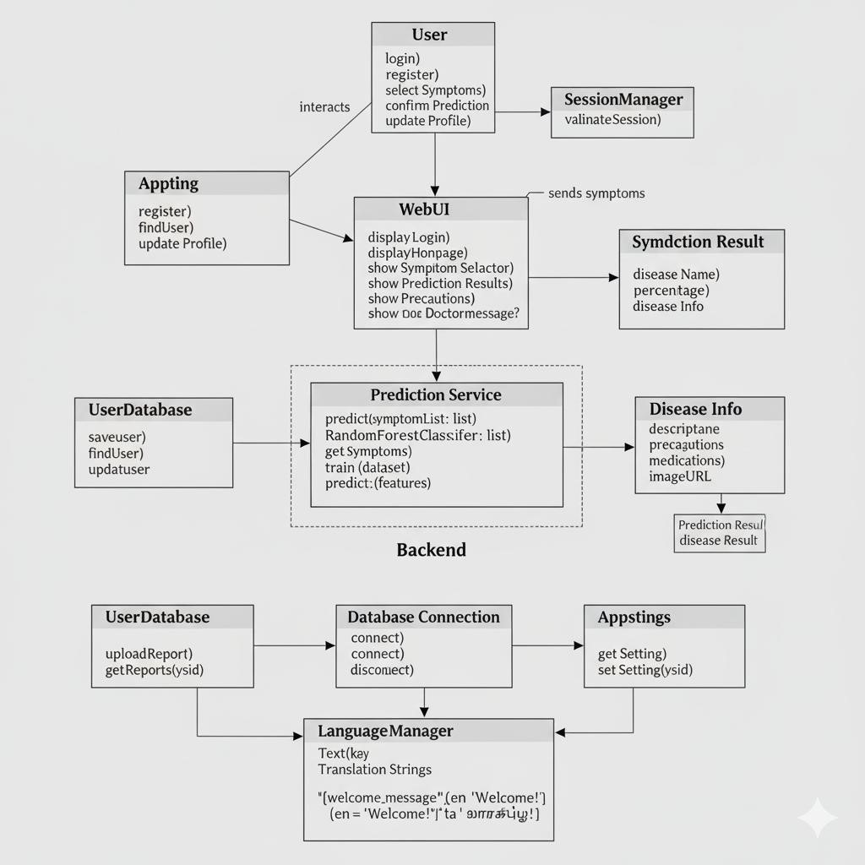

**Fig.4.3.3.4 Class Diagram**

**4.3.3.5 DFD Diagrams:**

**4.3.3.5 DFD Level-0**

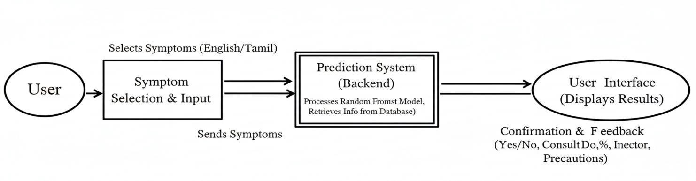

**Fig.4.3.3.5 DFD Level-0 Diagran**

**4.3.3.5 DFD Level-1**

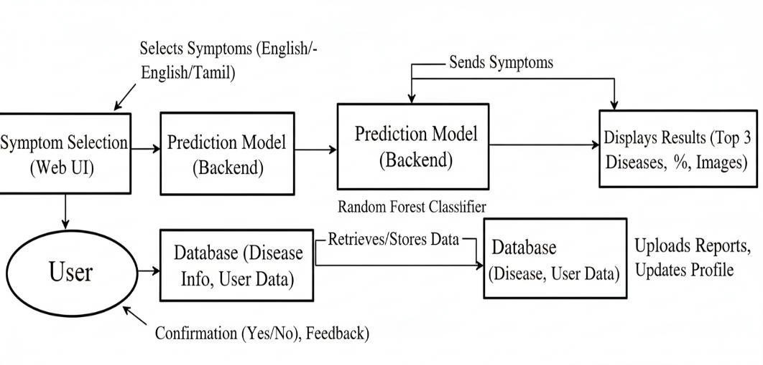

**Fig,4.3.3.5 DFD Level-1 Diagram**

**4.3.3.5 DFD Level-2**

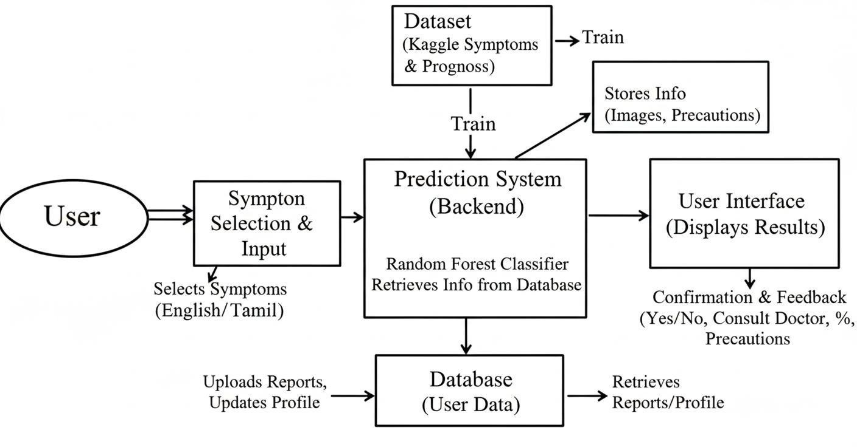

**Fig.4.3.35 DFD Level-2 Diagram**

**4.3.3.6 Collaboration Diagram:**

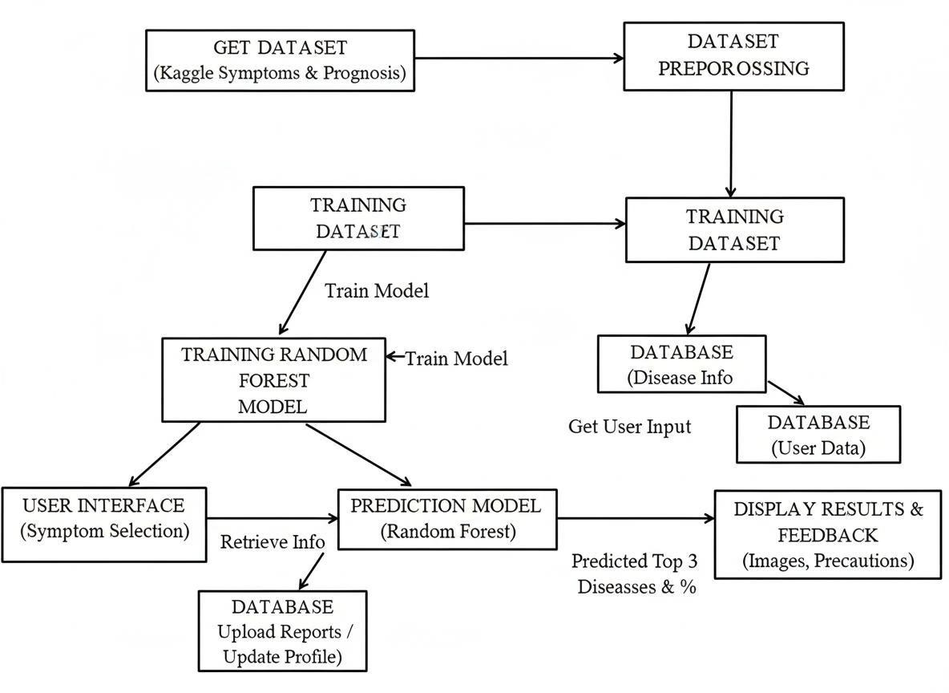

**Fig.4.3.3.6 Collaboration Diagram**

**SYSTEM**

### IMPLEMENTATION

**########################################**

**5. System Implementation**

#### 5.1 Modules:

* Dataset Exploration and Preparation
* Image Augmentation and Preparation

* Model Training and Optimization
* Input Image Processing and Classification

* User Interface and Deployment

**5.1.1 Dataset Exploration and Preparation**

The success of any machine learning-based system, particularly in healthcare, heavily depends on the quality and organization of the dataset. For this project, a comprehensive dataset containing symptoms and their corresponding disease outcomes was sourced from **Kaggle**, a widely trusted platform for datasets. The dataset serves as the foundation for training the model, and any inaccuracies or inconsistencies could significantly affect prediction results.

The initial step involved downloading the dataset and carefully examining its structure to understand the distribution of symptoms and diseases. This analysis included identifying missing values, duplicates, and any anomalies in the data. Data cleaning was performed meticulously to ensure that only accurate and relevant information was retained. Each symptom was mapped correctly to its respective disease, and the data was structured into a format compatible with machine learning algorithms.

Organizing the dataset in a systematic manner plays a crucial role in improving the efficiency of data retrieval and processing. By clearly defining each disease category, the model can learn distinctive features of each condition more effectively, reducing the chances of misclassification. Furthermore, a well- prepared dataset ensures consistency in training, leading to higher accuracy and more reliable predictions. Once the dataset was cleaned and structured, it was stored securely for further preprocessing and model training, forming the cornerstone of the entire skin disease prediction system.

**5.1.2 Image Augmentation and Preparation**

Visual representation is a vital component of a skin disease prediction system, as it allows users to correlate symptoms with actual images of diseases. To achieve this, images of various skin conditions were collected and carefully prepared. Image preprocessing began with resizing all images to a uniform dimension, ensuring consistency across the dataset. Normalization was applied to standardize pixel values, which improves the model’s learning efficiency. To enhance the robustness of the system, **image augmentation techniques** were employed. This included rotation, flipping, zooming, and adjusting brightness levels. These techniques effectively increase the diversity of the dataset without the need to collect additional images, enabling the model to generalize better to real-world scenarios. Properly prepared and augmented images also allow the system to provide visual references alongside predictions, helping users to understand and verify the results more intuitively. This step ensures that the model can recognize patterns across a wide variety of images, making predictions more accurate and reliable.

**5.1.3 Model Training and Optimization:**

Once the dataset was thoroughly prepared, the next step involved training a **Random Forest Classifier**, chosen for its robustness, ability to handle multi-class classification, and interpretability. The dataset was divided into training and testing sets, ensuring that the model could be evaluated on unseen data to measure its real-world performance.

During training, the model learned the intricate relationships between user- selected symptoms and possible diseases. Hyperparameter tuning was performed to optimize the model’s performance, adjusting parameters such as the number of decision trees, maximum depth, and feature selection strategies.

The trained model is capable of predicting the **top three probable diseases** for any combination of symptoms and provides the corresponding probability percentages, giving users insight into the likelihood of each disease. This step is critical, as proper training and optimization directly influence the system’s reliability, accuracy, and usability in real-world healthcare scenarios.

**5.1.4 Input Image Processing and Classification** :

The system is designed to be highly interactive and user-friendly, allowing users to input their symptoms through a **web-based interface**. Upon input, the system validates the data to ensure completeness and correctness. This validation step is crucial to prevent errors that could lead to incorrect predictions. Once validated, the symptoms are preprocessed and formatted to be compatible with the trained model.

The model then performs classification, predicting the most probable diseases based on the provided inputs. Alongside predictions, images representing the predicted conditions are displayed to help users verify the results visually. Users are asked to confirm whether the predicted disease matches their symptoms.

If confirmed, the system provides **appropriate precautions and suggested medications**. If the prediction does not match, the system recommends consulting a medical professional, ensuring that users are guided safely. This module forms the core of the system, bridging the gap between user input and actionable healthcare advice.

.

**5.1.5 User Interface and Deployment:**

To make the system accessible to a broad audience, a **user-friendly web interface** was developed. The interface includes several key pages, such as **Registration, Login, Forgot Password, Update Profile, Upload Reports, Settings, About Skin, and the Predictor App**, each designed for smooth and intuitive interaction. Special emphasis was given to **bilingual support**, enabling users to access the system in both **English and Tamil**.

This feature ensures inclusivity, allowing non-English speakers to benefit from the system. The interface provides clear guidance throughout the prediction process, from selecting symptoms to viewing predictions and suggested precautions.

The deployment phase ensures that the system operates seamlessly, integrating the trained model with the web interface to provide real-time predictions. By combining machine learning accuracy with a visually appealing and easy-to-navigate interface, the system empowers users to perform preliminary assessments of skin conditions while promoting timely medical consultation. This module encapsulates the project’s goal of delivering an accessible, reliable, and user-centric skin disease prediction tool.

RESULTS &

DISCUSSIONS

# 6. Results & Discussions

# 6.1 Testing:

**6.1.1 Unit Testing:**

Unit testing involves testing individual components or modules of the system to verify that each part functions correctly. For the Career Suggestion Website, key modules such as student details input, skill selection, stream recommendation, and career suggestion were tested separately to ensure accuracy and reliability.

|  |  |  |  |  |
| --- | --- | --- | --- | --- |
| Process | Test Case |  | Expected Result | Status |
| Student Details Input | |  | | --- | | Enter basic student information |  |  | | --- | |  | |  | Details are stored correctly in the database | Pass |
| Grade Selection | Select 10th or 12th grade |  | Student redirected to the correct module | Pass |
| Skill Selection (10th) | Select multiple soft skills |  | Skills saved accurately and reflected in recommendation | Pass |
| Stream Suggestion (10th) | Generate streams based on selected skills |  | Correct streams displayed based on chosen skills | Pass |
| Stream Selection (12th) | Choose existing academic stream | | Stream correctly saved for further processing | Pass |
| Skill Selection (12th) | Select both stream-related and additional skills | | Skills saved accurately for personalized career suggestions | Pass |
| Career Suggestion  Logout Module | Generate careers based on skills and stream  Click logout button | | Relevant careers displayed with current and lacking skills  User successfully logged out | Pass  Pass |

###### Table6.1.1 Unit Testing

**6.1.2 Integration Testing:**

Integration testing is the process of evaluating how different components or modules of a system work together as a complete unit. Unlike unit testing, which focuses on testing individual components separately, integration testing examines the interactions between modules to identify interface errors, data flow issues, and logical inconsistencies. In the context of the Career Suggestion Website, integration testing ensures that modules such as student detail input, grade selection, skill selection, stream recommendation, and career suggestion function cohesively.

During integration testing, data passed between modules is closely monitored to confirm that information is correctly transmitted and processed. For example, the system checks that student details collected in the first module are accurately used to determine the appropriate grade-based interface, and that selected skills are correctly analyzed to generate suitable academic streams. Similarly, for 12th-grade students, the interaction between stream selection and skill-based career suggestions is tested to ensure that career recommendations align with the student’s input.

The goal of integration testing is to verify that all modules work together seamlessly and that the system behaves as expected in real-world scenarios. Proper integration testing helps to detect and resolve issues such as incorrect data mapping, workflow interruptions, or missing information before the system is deployed. This testing phase is crucial for delivering a reliable and stable system, as it confirms that the individual components not only function correctly on their own but also integrate effectively to provide accurate and meaningful results to the user.

**6.1.3 Functional Testing:**

Functional testing is the process of verifying that the system performs all its intended functions according to the specified requirements. It focuses on validating the **features and functionalities** of the system rather than the underlying code or structure. In the context of the Career Suggestion Website, functional testing ensures that all modules, including student details input, grade selection, skill selection, stream recommendation, and career suggestion, work correctly and produce the expected outputs.

During functional testing, each function of the system is checked to ensure it behaves as expected under different conditions. For example, the system is tested to confirm that students are correctly categorized into 10th or 12th grade based on their input, that selected skills are accurately recorded, and that appropriate streams and career suggestions are displayed according to the student’s skillset and academic background. Functional testing also verifies the system’s ability to handle invalid inputs or unexpected user actions gracefully, ensuring that errors are managed properly without crashing the application.

The main objective of functional testing is to validate that the system meets the functional requirements outlined during the design phase. By performing functional testing, developers and testers can identify and correct discrepancies between the system’s behavior and its specifications. This type of testing ensures that the Career Suggestion Website is **reliable, accurate, and user-friendly**, providing students with a seamless experience while delivering correct skill-based career recommendations.

.

**6.1.4 System Testing:**

System testing is the process of evaluating the complete and integrated system to verify that it meets the specified requirements and performs as intended in a real-world environment. Unlike unit or integration testing, which focus on individual components or module interactions, system testing examines the entire Career Suggestion Website as a whole, ensuring that all features work together seamlessly.

During system testing, the overall functionality, usability, performance, and reliability of the website are assessed. This includes verifying that students can successfully enter their details, select their grade, choose their skills, and receive accurate stream and career suggestions. The system is tested for proper handling of various scenarios, such as multiple skill selections, different grade inputs, or unusual user interactions, to ensure it responds correctly without errors or crashes.

The objective of system testing is to validate that the application meets all functional and non-functional requirements. It helps detect issues related to user interface, data processing, workflow consistency, and overall system behavior before deployment. System testing ensures that the Career Suggestion Website is fully functional, reliable, and user-friendly, providing a seamless experience for students while delivering accurate, skill-based career recommendations.

**6.1.5 User Acceptance Testing (UAT):**

User Acceptance Testing (UAT) is the final phase of testing in which the system is evaluated by the actual end users to determine whether it meets their requirements and expectations. Unlike other testing types that focus on technical correctness, UAT focuses on usability, functionality, and user satisfaction. For the Career Suggestion Website, UAT involves students, teachers, and career counselors using the platform to ensure that it provides meaningful, accurate, and understandable career recommendations.

During UAT, end users perform real-world tasks such as entering student details, selecting grades and skills, and checking the suggested streams and careers. Feedback is collected to assess whether the system is intuitive, user-friendly, and capable of guiding students effectively in making informed career choices. UAT also evaluates how well the system handles errors, such as invalid inputs or incomplete data, and whether the output matches the expectations of students and educators.

The main objective of UAT is to confirm that the system fulfills the intended purpose from the user’s perspective. By conducting UAT, developers can identify any gaps between the system’s design and actual user needs, and make necessary improvements before full deployment. Successful UAT ensures that the Career Suggestion Website is reliable, effective, and ready for real-world use, providing students with a practical and interactive tool for career guidance.

**6.1.6 Test Cases and Result: #####**

|  |  |  |  |  |  |  |
| --- | --- | --- | --- | --- | --- | --- |
| **Test**  **Case**  **ID** | **Test Scenario** | **Test Steps** | | **Expected**  **Result** | **Actual**  **Result** | **Status** |
| TC01 | Symptom  Input  Validation | Select valid symptoms from  list | | Input processed correctly | As    expected | Pass |
| TC02 | Invalid Symptom  Handling | Enter unrelated symptom | | Error message:  "Consult a  doctor" | As    expected | Pass |
| TC03 | Prediction Accuracy | Submit valid  symptoms | | Top 3 diseases with percentages displayed | As  expected | Pass |
| TC04 | Image  Display | Confirm prediction | | Correct images displayed | As expected | Pass |
| TC05 | Precaution/M edicine Display | Confirm disease |  | Appropriat e precaution s and  medicines shown | As expected | Pass |
| TC06 | UI Response &  Display | Test multiple devices | on | Interface adapts and works  smoothly | As expected | Pass |

###### Table.6.1.6 Test Cases

## 6.2 Results and Discussions:

The Career Suggestion Website was successfully developed and tested to provide personalized guidance for students in the 10th and 12th grades. The system collects basic student details, evaluates their skills, and generates recommendations for suitable academic streams and career paths. This skill-based approach ensures that the suggestions are tailored to each student’s abilities, interests, and educational background, providing a structured and practical framework for career decision-making.

Extensive testing was performed at multiple levels, including unit testing, integration testing, functional testing, system testing, and user acceptance testing (UAT). Unit testing verified that individual components, such as student detail input, grade selection, skill selection, and career suggestion, function correctly on their own. Integration testing confirmed that the modules interact seamlessly, ensuring smooth data flow between different sections of the website. Functional testing validated that each feature behaves as expected under various scenarios, while system testing assessed the performance, usability, and reliability of the complete system. Finally, UAT confirmed that students and educators could use the platform effectively, providing feedback that validated the system’s practical utility.

The results indicate that the system accurately captures student inputs and provides relevant stream and career suggestions. For 10th-grade students, the platform successfully matches soft skills such as critical thinking, communication, and problem-solving to appropriate streams like Biomaths, Computer Science, Commerce, or Arts. For 12th-grade students, the system combines their existing streams with skill evaluation, including additional talents, to generate personalized career recommendations. In all cases, the system also highlights skill gaps, enabling students to understand which abilities need further development to succeed in their chosen careers.

The platform proved to be user-friendly and accessible, allowing students to navigate through different sections, select their skills, and view career suggestions with minimal guidance. Students can also track their strengths and weaknesses, which helps in planning academic and extracurricular activities strategically. This approach reduces the reliance on traditional career counseling methods, which may be inconsistent, subjective, or unavailable in some schools.  
The results and observations confirm that the Career Suggestion Website is an effective, reliable, and practical tool for career planning. By integrating skill analysis with academic streams and career options, it empowers students to make informed decisions confidently. The system not only provides guidance on suitable career paths but also encourages self-assessment and skill development, which are critical for long-term educational and professional success. Additionally, the online platform ensures accessibility for a wide range of students, overcoming geographical and resource limitations that often restrict access to conventional career counseling.

Overall, the system demonstrates significant potential to improve career guidance for school students. Its structured, data-driven approach provides a clear understanding of students’ abilities, helping them choose academic streams and careers that align with their skills and interests. The results confirm that the platform is both practical and impactful, making it a valuable resource for students, parents, and educators.

# 

# CONCLUSION & FUTURE WORK

## 

## 7. Conclusion

**7.1 Conclusion:**

Choosing the right career path is one of the most important decisions for students, especially those in the 10th and 12th grades. Traditional career guidance methods are often limited, inconsistent, or inaccessible, leaving many students uncertain about their academic and professional futures. The Career Suggestion Website addresses this issue by providing a personalized, skill-based, and structured approach to career guidance.

The system effectively collects student details, evaluates both academic and soft skills, and generates suitable stream and career recommendations. For 10th-grade students, the platform matches selected soft skills with appropriate academic streams, while for 12th-grade students, it considers both the existing stream and additional skills to provide personalized career suggestions. The system also highlights skill gaps, enabling students to identify areas for improvement and plan their skill development strategically.

Testing at multiple levels—including unit, integration, functional, system, and user acceptance testing—confirmed that the system is reliable, accurate, and user-friendly. The platform ensures smooth interaction between modules, handles both valid and invalid inputs effectively, and provides results that align with students’ skills and interests. User feedback further validated that the system is practical, intuitive, and helpful in guiding career decisions.

In conclusion, the Career Suggestion Website is a robust and efficient tool for supporting students in making informed academic and career choices. It not only improves access to career guidance but also encourages self-assessment, skill awareness, and thoughtful decision-making. This platform has the potential to significantly enhance career planning for students, empowering them to choose educational streams and careers that best align with their abilities and aspirations.

## 7.2 Future Work:

The Career Suggestion Website can be further enhanced in the future to provide a more comprehensive and interactive career guidance experience. One potential improvement is the integration of **AI and machine learning algorithms** to analyze student behavior, preferences, and performance patterns, enabling even more accurate and personalized career recommendations.

Additionally, the platform can incorporate **psychometric and aptitude tests** to provide deeper insights into a student’s strengths, interests, and personality traits. Integration with **real-world career databases, industry trends, and internships** could help students explore emerging opportunities and plan their education and skill development accordingly.

Other possible enhancements include developing a **mobile application**, adding **multi-language support**, and including **interactive tutorials or mentorship modules** to guide students through career decision-making processes. By implementing these future improvements, the system can become a **comprehensive, intelligent, and globally accessible career guidance platform** that effectively supports students in achieving their academic and professional goals.

**APPENDICES**

## A.1 SDG Goals

**1. Quality Education (SDG 4)**

The Career Suggestion Website promotes inclusive and quality education by providing personalized guidance to 10th and 12th-grade students. It helps students identify their skills, strengths, and areas for improvement, enabling informed decisions about academic streams. The platform is accessible online, allowing students from remote areas to benefit equally. It encourages self-awareness, critical thinking, and active learning. By integrating skill assessment with career guidance, the system enhances learning outcomes and supports SDG 4.

**2. Decent Work and Economic Growth (SDG 8)**

The system supports sustainable economic growth by guiding students toward careers aligned with their skills and interests, improving future employability. It highlights skill gaps and promotes lifelong learning, preparing students for workforce demands. Early career guidance reduces the risk of unemployment and encourages productive career choices. By providing data-driven recommendations, the platform ensures students are prepared to contribute meaningfully to the economy, supporting SDG 8.

**3. Reduced Inequalities (SDG 10)**

The Career Suggestion Website reduces inequalities by providing equal access to career guidance regardless of socio-economic background or location. Students without personal counselors can receive tailored recommendations based on their skills and interests. The system recognizes diverse talents and ensures unbiased guidance, empowering all students to pursue suitable educational and career opportunities. This promotes fairness, inclusion, and equal access, aligning with SDG 10.

**4. Industry, Innovation, and Infrastructure (SDG 9)**

The platform leverages digital technology to deliver innovative career guidance, demonstrating the use of IT infrastructure in education. It provides an interactive, scalable solution that can be accessed from any location, promoting technological inclusion. The system encourages the integration of new digital tools in learning and career planning, fostering innovation in the education sector. By combining technology with education, it supports SDG 9 by promoting sustainable infrastructure, digital learning, and innovation.

## ########################3

## A.2 Source Code

**Coding:**

##############################

**A.3 Screenshots**

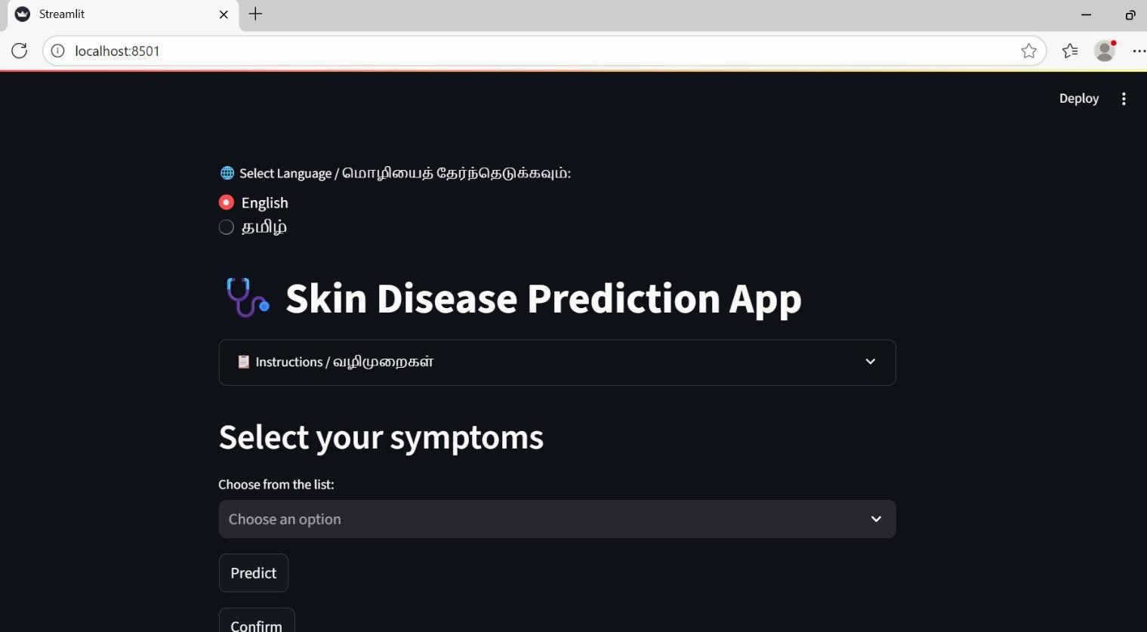

**Fig.A.3.1 User Interface**

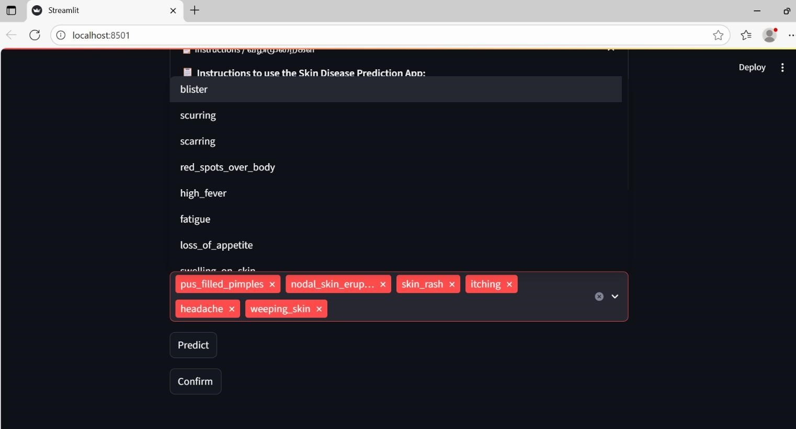

**Fig.A.3.2 Select Symptoms**

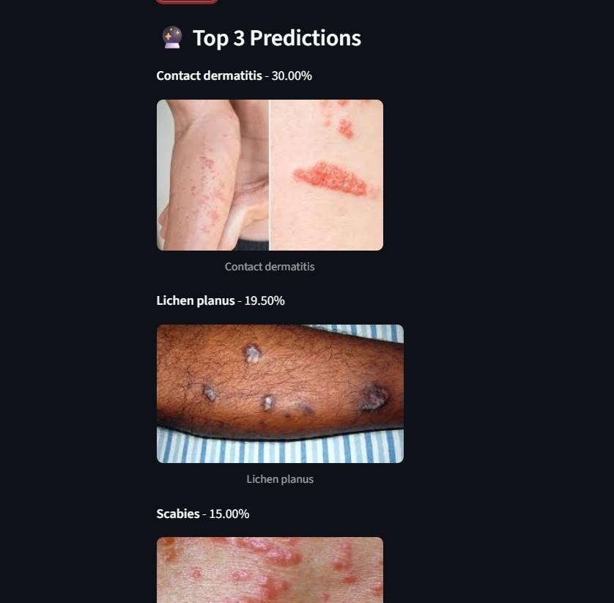

**Fig.A.3.3 Prediction results (Top 3 diseases with probability)**

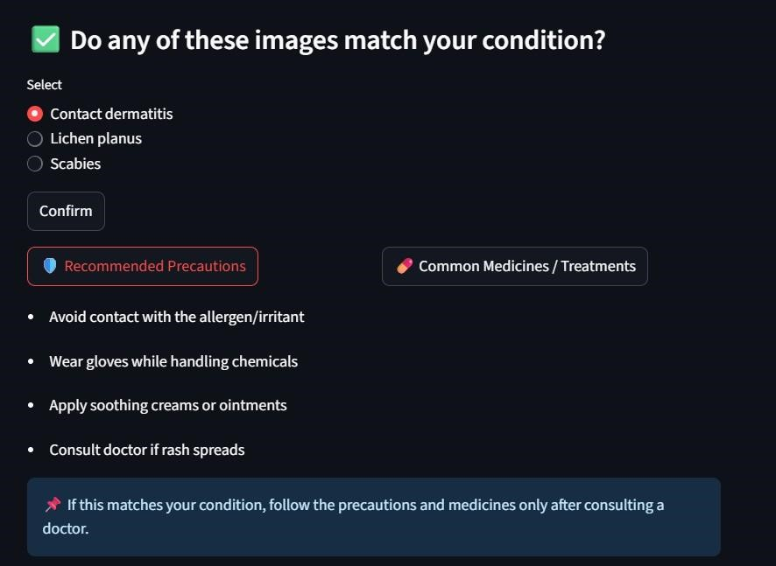

**Fig.A.3.4 Result**

**###################################**

**A.4 Plagiarism Report**

**Fig.A.4 Plagiarism Report**

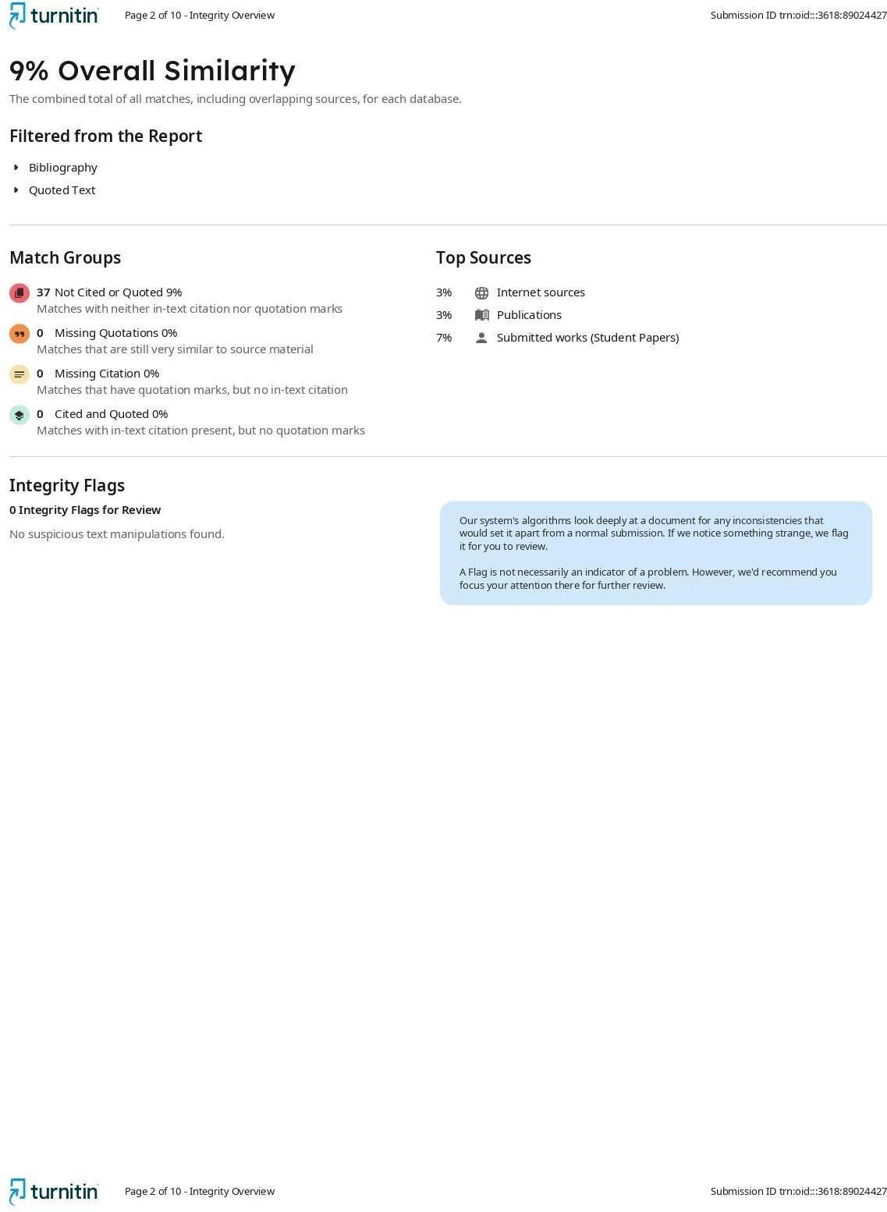

**#########**

**REFERENCES**

**References**

1. ISRAT YASMIN, SURIYA SULTANA, SYEDA JOBAIDA BEGUM

“Impact of Fuzziness for Skin Lesion Classification with Transformer-Based

Model”, in IEEE International Conference(2023)

1. S.ARULMURUGAN, A.M.AAMIR, K.KALANITHI “Skin Disease

Diagnosis using Mini-batch Fuzzy C-Means Clustering and CNN”, in IEEE International Conference(2024)

1. S.SOFANA REKA, H.LEELA KARTHIKEYAN, A.JACK SHAKIL

“Exploring Quantum Machine Learning for Enhanced Skin Lesion Classification:

A Comparative Study of Implementation Methods”, in IEEE International

Conference(2024)

1. R.KARTHIK, R.MENAKA, SHIVANSH ATRE, JAEHYUK CHO “A

Hybrid Deep Learning Approach for Skin Cancer Classification Using Swin

Transformer and Dense Group Shuffle Non-Local Attention Network”, in IEEE International Conference(2024)

1. H.M.LAYES DELOWER, TASIN MOHAMMAD, SHIFATH JAHAN

PRITY “Skin Lesion Detection and Classification Using Machine Learning: A Comprehensive Approach for Accurate Diagnosis and Treatment”, in IEEE International Conference(2023)

1. Esteva, A., Kuprel, B., Novoa, R. A., Ko, J., Swetter, S. M., Blau, H. M., & Thrun, S."Dermatologist-level classification of skin cancer with deep neural networks.", in IEEE (2017)
2. Li, X., Shen, L., Xie, X., & Zhang, Y. "Ensemble deep learning model for skin lesion classification using MobileNet and Inception." IEEE Access(2021)
3. Abbas, Q., Celebi, M. E., & Garcia, I. F. "Dermoscopic image analysis: A review of classic and deep learning approaches." Artificial Intelligence in

Medicine ,IEEE (2019)

1. Yu, L., Chen, H., Dou, Q., Qin, J., & Heng, P. A."Automated melanoma recognition in dermoscopy images via very deep residual networks." IEEE

Transactions on Medical Imaging(2017)

1. Kawahara, J., Daneshvar, S., Argenziano, G., & Hamarneh, G. "Seven-point checklist and skin lesion classification using multitask deep learning." IEEE

Transactions on Biomedical Engineering(2018)

1. Szegedy, C., Vanhoucke, V., Ioffe, S., Shlens, J., & Wojna, Z."Rethinking the inception architecture for computer vision." Proceedings of the IEEE Conference on Computer Vision and Pattern Recognition (CVPR)(2016)
2. A. K. Gupta, S. K. Gupta, and A. K. Jain, "Skin lesion classification using deep learning: A review," IEEE Access(2020)
3. A. M. Alzubaidi, A. A. A. Alhussein, and A. A. Alhussein, "Skin cancer detection using deep learning: A review," IEEE Access(2021)
4. J. Y. Lee, H. J. Kim, and S. H. Kim, "Deep learning in dermatology: A review," IEEE Transactions on Medical Imaging(2020)
5. M. A. A. Rahman, M. A. H. Chowdhury, and M. A. H. Khan, "Skin lesion classification using convolutional neural networks: A review," IEEE

Access(2020)